

**PIMPRI CHINCHWAD COLLEGE OF ENGINEERING**

**BACHELOR OF VOCATION ( B.VOC )**

**IN**

**INTERNET OF THINGS ( IoT )**

**A PROJECT REPORT ON :**

# SMART BLIND STICK USING ESP-WROOM-32

**Prepared by:  
Yash Ghige [123V1I005]**

**Sakshi Taware [123V1I026]**

**Vaishnavi Dhakane [ 123V1I003]**

**Guide Name: Ms. Suvarna Kadam**  
  
***Department of BACHELOR OF VOCATION [ IOT ]***

***ACADEMIC YEAR : 2024-25***

*March 2025*

INDEX

|  |  |  |
| --- | --- | --- |
| SR.NO. | TOPIC | PAGE N0. |
| 1 | Abstract | 3 |
| 2 | ESP-WROOM-32 | 3-7 |
| 3 | Introduction | 7 |
| 4 | Literature Review | 7-9 |
| 5 | Feasibility Analysis | 9 |
| 6 | System Design | 9-14 |
| 7 | Implementation | 14-16 |
| 8 | Methodology | 17-20 |
| 9 | Expected Outcome | 20-21 |
| 10 | Future Scope | 21-22 |
| 11 | Conclusion | 23 |
| 12 | References | 23 |
|  |  |  |

**Abstract**

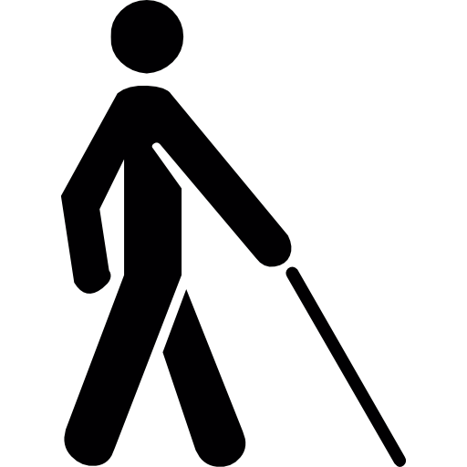

This project focuses on designing and implementing a Smart Blind Stick using ESP-WROOM-32 to aid visually impaired individuals in navigating their surroundings safely and independently. The system is built with an ultrasonic sensor, continuously scanning for obstacles in the user's path. When an obstacle is detected within a predefined range, the system provides real-time feedback through a buzzer, alerting the user to the presence of an object ahead.

The primary objective of this project is to offer a cost-effective and user-friendly solution that enhances mobility for the visually impaired. The stick is lightweight, easy to handle, and designed to function efficiently in different environments. Additionally, this system has the potential for future enhancements, such as GPS integration for location tracking and voice assistance to provide verbal guidance, further improving its usability and effectiveness.

## Detailed Overview of ESP-WROOM-32 :

### Introduction to ESP-WROOM-32:

The **ESP-WROOM-32** is a highly integrated and versatile microcontroller module developed by **Espressif Systems**, based on the **Tensilica Xtensa LX6 dual-core 32-bit processor**. It is designed for a wide range of **IoT (Internet of Things)** and embedded applications due to its built-in support for both **Wi-Fi** and **Bluetooth (Classic + BLE)**.

This module offers a rich set of features including:

* Multiple **GPIO pins** for digital I/O interfacing,
* **Analog inputs (ADC)** and **PWM outputs**,
* **SPI, I2C, UART**, and other communication protocols.

The ESP-WROOM-32 provides an ideal balance between **performance and power efficiency**, making it suitable for battery-operated smart devices like the **Smart Blind Stick**. Its extensive community support and compatibility with programming platforms such as the **Arduino IDE** and **ESP-IDF** (Espressif IoT Development Framework) make it beginner-friendly while still offering professional-grade capabilities.

Overall, the ESP-WROOM-32 serves as the core processing unit for the Smart Blind Stick, efficiently managing real-time sensor data and triggering output responses like buzzer alerts.

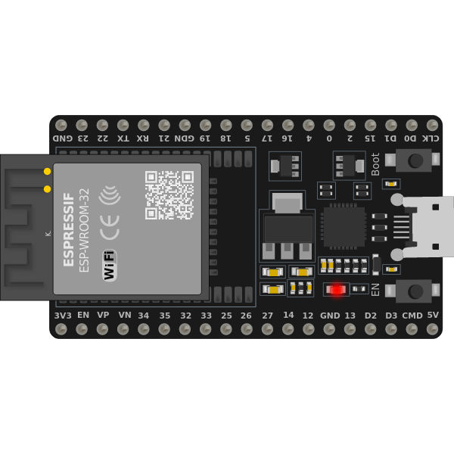

Fig. 1 ESP-32 BOARD

### Hardware Component Specifications

The **ESP-WROOM-32** is a powerful, low-cost microcontroller module developed by **Espressif Systems**, designed for embedded and IoT applications. It integrates multiple essential hardware components suitable for smart systems like the Smart Blind Stick. The key specifications are as follows:

#### ****Microcontroller:****

* **ESP- WROOM-32**, a dual-core microcontroller based on the **Xtensa LX6 architecture**, featuring:
  + **520KB SRAM** (for data processing and memory)
  + **4MB Flash memory** (for program storage and firmware)

#### ****Clock Speed:****

* Operates at up to **240 MHz**, allowing high-performance processing for real-time tasks such as sensor input and output control.

#### ****Digital Input/Output (I/O) Pins:****

* Up to **34 programmable GPIO pins** to interface with external components.
* Includes support for **PWM**, enabling precise control of devices like motors and buzzers.

#### ****Analog Input Pins:****

* Includes **18 ADC channels** (12-bit resolution) for interfacing with analog sensors.

#### ****Power Supply Options:****

* Can be powered through:
  + **Micro-USB (5V)** connection for development and programming.
  + **VIN Pin (3.3V–5V)** for external battery or regulated power supply.

#### ****Communication Interfaces:****

* **UART** – For serial communication with modules and debugging.
* **I2C** – For interfacing with sensors and peripherals using two-wire communication.
* **SPI** – For high-speed communication with external modules like displays and memory.
* **Wi-Fi 802.11 b/g/n** – For wireless data transmission and cloud connectivity.
* **Bluetooth v4.2 (Classic + BLE)** – For short-range wireless communication with smartphones or other devices.

#### ****USB Interface:****

* Equipped with a **Micro-USB interface** for programming using the **Arduino IDE** or **ESP-IDF**.
* Also used for **serial debugging and firmware upload**.

These hardware features make the **ESP-WROOM-32** a **robust and versatile microcontroller platform** for developing smart systems such as the Smart Blind Stick. Its **dual-core performance**, built-in **Wi-Fi/Bluetooth**, and **rich GPIO set** make it ideal for interactive and real-time applications.



FIG. 2 ESP-WROOM-32 HARDWARE SPECIFICATIONS

### Software and Programming

The **ESP-WROOM-32** is programmed using the **Arduino IDE or ESP-IDF**, both of which support C and C++ programming languages. The development environment provides a user-friendly interface for writing, compiling, and uploading code to the microcontroller via USB.

One of the key advantages of these environments is the built-in libraries, which simplify complex tasks such as serial communication, sensor data processing, and Pulse Width Modulation (PWM) control. These libraries allow developers to interact with various hardware components without needing to write low-level code. The IDE also includes a serial monitor for real-time debugging, making it easier to test and troubleshoot ESP-WROOM-32 -based projects.

• **Programming Structure:**

* **#** void setup(): Initializes pins, sensors, and other configurations.
* # void loop(): Runs continuously to execute project logic.

• **Programming Example:**

**void setup() {  
 pinMode(13, OUTPUT);  
 }  
 void loop() {  
 digitalWrite(13, HIGH);  
 delay(1000);  
 digitalWrite(13, LOW);  
 delay(1000);  
 }**

### ****Why Use ESP32-WROOM-32CHIP ?****

**User-Friendly**: The **ESP-WROOM-32** features a simple programming interface, making it easy for beginners to learn and develop projects. Its large online community also provides extensive support, tutorials, and troubleshooting resources.

**Versatile**: It is widely used in various applications, including robotics, IoT (Internet of Things), home automation, and embedded systems. Its ability to interface with various sensors, motors, and modules makes it a flexible choice for multiple projects.

**Cost-Effective**: Compared to other microcontroller platforms, the ESP-WROOM-32 is affordable while still offering powerful features, making it ideal for students, hobbyists, and professionals.

**Cross-Platform Compatibility**: The Arduino IDE and ESP-IDF are compatible with Windows, Linux, and macOS, ensuring seamless programming across different operating systems.

## Introduction

Visually impaired individuals often encounter challenges in safely navigating their surroundings. Traditional **white canes** require **physical contact** with obstacles before detection, which can pose risks, especially in unfamiliar or crowded environments. This limitation increases the chances of accidents and restricts independent movement.

To overcome this issue, an **ESP-WROOM-32 based Smart Blind Stick** has been developed. This system enhances **safety and mobility** by detecting obstacles **in advance** and providing real-time alerts. Equipped with **ultrasonic sensors**, a **buzzer**, and a , the Smart Blind Stick warns users of nearby objects before contact occurs.

This early-warning mechanism **reduces the risk of collisions** and promotes greater **independence** for visually impaired individuals.

## Literature Review

Assistive technology for visually impaired individuals has significantly progressed with the use of advanced microcontrollers like the **ESP-WROOM-32**. This module offers **dual-core processing, low power consumption**, and **built-in Wi-Fi and Bluetooth**, making it highly suitable for real-time assistive applications such as **smart blind sticks**. Several studies have demonstrated how this technology enhances **obstacle detection, user feedback, and IoT-based monitoring**.

### ****2.1 Use of ESP-WROOM-32 in Smart Blind Sticks****

Recent research supports the effectiveness of ESP32-based modules in developing smart assistive devices.  
**Arepalli et al. [1]** developed a smart blind stick that used **ESP-WROOM-32**, ultrasonic sensors, and a to detect and alert users about nearby obstacles. The study emphasized the **Wi-Fi and Bluetooth capabilities** of the module for integrating GPS and real-time alert systems.

Similarly, **Hasan et al. [2]** proposed a **low-power blind stick** using ESP-WROOM-32. The device transmitted user movement data to caregivers using **wireless connectivity**, highlighting the ESP32's role in **remote safety monitoring**.

### ****2.2 Sensor-Based Obstacle Detection and Feedback Systems****

The role of **ultrasonic and infrared sensors** in assistive technologies is well-established. **Sharma et al. [3]** implemented a blind stick with dual ultrasonic sensors at different angles to detect both **head-level and ground-level obstacles**. When used with ESP-WROOM-32, the **dual-core processor** enabled faster response and better multitasking of sensor input and alert activation.

**Kumar et al. [4]** extended this concept by adding a **moisture sensor** to detect wet surfaces. The ESP-WROOM-32 processed this data to alert users about **slippery areas**, reducing accident risk. They further suggested that **machine learning algorithms** could be implemented on the module for **advanced obstacle classification**.

### ****2.3 IoT and Cloud Integration for Enhanced Safety****

ESP-WROOM-32's **built-in Wi-Fi and BLE** make it ideal for **IoT applications**. **Nasir et al. [5]** designed a GPS-enabled smart stick that transmitted **real-time location data** to caregivers via cloud platforms. The integration of ESP-WROOM-32 allowed for **continuous monitoring and remote alerts**.

**Pagar et al. [6]** introduced a voice-assisted blind stick using ESP32-WROOM-32. Their work highlighted how the module’s **multimedia support and wireless connectivity** could improve user interaction through **audio alerts**, making the system more intuitive for the visually impaired.

### ****2.4 Summary of Literature Findings****

The reviewed studies suggest that **ESP-WROOM-32** enhances smart blind stick functionality in the following ways:

* Enables **real-time obstacle detection** using ultrasonic and moisture sensors.
* Provides **faster processing** and better multitasking with its **dual-core architecture**.
* Supports **IoT integration** for GPS tracking and caregiver notifications.
* Offers **Bluetooth and Wi-Fi** for wireless feedback and mobile connectivity.
* Enables **advanced features** like voice alerts and AI-based obstacle detection.

## Feasibility Analysis

### Technical Feasibility

• Uses **widely available components** such as **ultrasonic sensors,** and buzzer.  
• **Simple programming** with basic coding skills.  
• **Easily assembled** with minimal expertise, making it suitable for **rapid prototyping**.

### Economic Feasibility

• **Cost-effective**: Estimated cost is **approximately ₹800-₹1200.**  
**• Low power consumption**: Operates on a **9V battery**, reducing maintenance costs.  
• Scalable for **future improvements**, including **IoT-based navigation** and **voice feedback integration**.

## System Design

### ****Working Mechanism****

The **Smart Blind Stick** operates using an **ultrasonic sensor, ESP-WROOM-32 , buzzer** to assist visually impaired individuals in detecting obstacles. The working process is as follows:

1. **Obstacle Detection:**
   * The **ultrasonic sensor** continuously emits ultrasonic waves and measures the time taken for the waves to reflect back from nearby objects.
   * This data is sent to the **ESP-WROOM-32** for processing.
2. **Alert Mechanism:**
   * If an obstacle is detected within **50 cm**, the **ESP-WROOM-32** triggers the **buzzer** to alert the user.
   * The buzzer produces an **audible alert**, ensuring accessibility in noisy environments.
3. **System Reset:**
   * Once the **obstacle is no longer detected**, the system **automatically resets**, turning off the buzzer.
   * This allows **continuous and real-time assistance** without manual intervention.

The system is designed to be **efficient, responsive, and easy to use**, ensuring that visually impaired users receive **immediate feedback** for safe navigation.

## Hardware and Software Requirements

• **ESP-WROOM-32** – Microcontroller unit.

• The **HC-SR04** is an ultrasonic distance sensor that measures distance by sending out a sound wave and timing how long it takes for the sound wave to bounce back after hitting an object. It uses two pins:

* **Trigger Pin (TRIG)**: Sends a short pulse to initiate the measurement.
* **Echo Pin (ECHO)**: Receives the pulse and measures how long it took to return, which is then used to calculate the distance.

#### ****Working Principle:****

* The **Trigger Pin** is sent a 10µs pulse, which causes the sensor to emit an ultrasonic wave.
* The **Echo Pin** listens for the return of the ultrasonic pulse.
* The time it takes for the pulse to return is proportional to the distance to the object.

#### ****Key Parameters:****

* **Range:** 2cm to 400cm
* **Accuracy:** Around 3mm
* **Operating Voltage:** 5V (but can also be used at 3.3V with some performance loss)
* **Operating Frequency:** 40kHz



FIG. 3 ULTRASONIC SENSOR (HC-SR04)

### ****2. Buzzer (Audio Alert)****

The **Buzzer** is used to provide an audio alert when an obstacle is detected within a predefined distance. It can be a **active** or **passive** buzzer:

* **Active Buzzer**: Emits a sound when powered on, making it simpler to use in your project.
* **Passive Buzzer**: Requires modulation of the signal to produce a tone (PWM or frequency modulation).

#### ****How it Works:****

When an obstacle is detected within a certain range (e.g., 30cm), the buzzer will be triggered by the Arduino code, producing an audible sound as a warning.

### ****3. Rechargeable Battery (Power Source)****

To make the project portable, you'll be using a **Rechargeable Battery** to power your ESP32 and sensors. Since the **ESP32** operates at 3.3V internally but has a **3.3V to 5V input range**, the battery chosen should meet those requirements.

#### ****Types of Batteries:****

* **Lithium-Ion (Li-Ion)** or **Lithium-Polymer (LiPo)** rechargeable batteries are good options for this project.
  + **Voltage:** Typically 3.7V nominal, and they charge to around 4.2V (depending on battery).
  + **Capacity:** Can range from 1000mAh to 3000mAh for portable projects.
* You can use a **boost converter** (e.g., MT3608) to step up the voltage to 5V if you want to power your HC-SR04 and ESP32 simultaneously from the battery.

#### ****Power Management:****

* **Voltage Regulator/Boost Converter**: This helps to ensure that your project gets a stable voltage from the battery.
* **Charging Module**: A **TP4056 charging board** is a great choice for safely charging Li-ion/LiPo batteries via micro-USB.

### ****4. Arduino IDE with ESP32 Board Support (Programming)****

You will program the **ESP32** using the **Arduino IDE**:

* **Install ESP32 Board Support**: Go to **File** → **Preferences**, add the ESP32 board manager URL in the **Additional Boards Manager URL** section. Then, install the ESP32 board from **Tools** → **Board** → **Boards Manager**.
* **Programming Language**: You’ll use C++ for programming the ESP32.

#### ****Basic Setup:****

* **Arduino IDE** will be used to write code to interact with the **HC-SR04**, **Buzzer**, and **Power Management** systems.
* **Serial Monitor** will allow you to monitor sensor readings in real-time for debugging.

### ****Connections and Power Flow:****

* **HC-SR04 Sensor** and **Buzzer** will both draw power from the **Rechargeable Battery** via the **ESP32**.
* The **Voltage Regulator** or **Boost Converter** ensures that all components receive the proper voltage, especially if using a 3.7V Li-ion battery.

### ****5. LM2596 Buck Converter Module****

The **LM2596** is a **step-down (buck) voltage regulator module** widely used in embedded and IoT projects to convert higher DC voltages into lower, stable voltages suitable for powering microcontrollers and other electronic components.

In this project, the **LM2596 module** is used to **regulate the voltage from a rechargeable battery (typically 7.4V or above)** down to a safe and stable **3.3V or 5V** output required by the **ESP32-WROOM-32** and other modules like sensors and buzzers.

#### ****Key Features:****

* **Input Voltage Range:** 4V to 40V DC
* **Adjustable Output Voltage:** 1.23V to 37V DC (via onboard potentiometer)
* **Maximum Output Current:** 2A (with heat sink, 1A without heat sink)
* **High Efficiency:** Up to 92%
* **Built-in Overheat and Short-Circuit Protection**
* **Onboard LED Indicator** for power status (on some modules)

#### ****Role in the Smart Blind Stick:****

* Ensures **stable voltage** supply to the ESP32 and other components.
* **Protects the circuit** from overvoltage or power fluctuations from the battery.
* Enhances **power efficiency** and helps extend battery life.

The compact size and reliability of the LM2596 make it ideal for use in portable, battery-powered devices like the **Smart Blind Stick**.

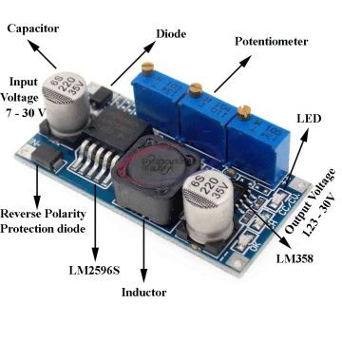

FIG. 4 LM2596 MODULE

**Detailed Circuit Design :**

The Smart Blind Stick’s circuit is designed for efficient real-time obstacle detection and audio alert response. The design integrates multiple modules, each playing a crucial role in the system’s operation:

1. **ESP32-WROOM-32 (Central Microcontroller Unit):**
   * Acts as the **brain of the system**, handling all processing and communication between input (HC-SR04 sensor) and output (Buzzer).
   * Uses **GPIO pins** to read the trigger and echo signals from the ultrasonic sensor and control the buzzer based on obstacle proximity.
   * Provides **serial communication** and is programmable via **Arduino IDE**.
2. **Ultrasonic Sensor – HC-SR04 (Obstacle Detection Module):**
   * Powered through the **5V output of the ESP32** or via a regulated power supply.
   * Measures the **distance to obstacles** using sound waves and provides real-time feedback.
   * Connected to ESP32 using two GPIO pins: **Trigger (to send signal)** and **Echo (to receive reflection)**.
   * Plays a **critical role** in detecting objects within the user's walking path.
3. **Buzzer (Audio Alert Module):**
   * Connected to one of the ESP32’s **digital output pins**.
   * **Activated** by the ESP32 when an obstacle is detected within a **predefined threshold distance** (e.g., 50 cm).
   * Provides **auditory feedback** to alert the user instantly.
4. **Rechargeable Battery (Power Source):**
   * Supplies power to the **entire system**, including ESP32 and peripheral modules.
   * Typically a **3.7V Li-ion or Li-Po battery**.
5. **LM2596 Buck Converter Module (Voltage Regulation Module):**
   * Steps down the **higher voltage from the battery** to a **stable 5V or 3.3V**, required by the ESP32 and HC-SR04 sensor.
   * Ensures **stable voltage supply**, preventing damage to components and enhancing power efficiency.
6. **Plastic Enclosure Box (Protective Housing):**
   * Holds all electronic components (ESP32, battery, voltage regulator) securely.
   * Ensures **portability, safety, and durability** of the system during use

### ****IMPLEMENTATION :****

The Smart Blind Stick project integrates essential electronic components for real-time obstacle detection and alert generation to aid visually impaired users. The system balances functionality with practical simplicity, using accessible components fitted inside a compact plastic box rather than a custom PCB layout.

### ****1. Hardware Implementation****

The hardware is assembled within a compact plastic enclosure mounted onto the stick, ensuring protection and ease of access for maintenance or upgrades. The key components include:

* **ESP-WROOM-32 Microcontroller:**  
  Acts as the central controller, reading sensor data and triggering alerts based on programmed logic.
* **Ultrasonic Sensor (HC-SR04):**  
  Mounted on the front of the stick, this sensor continuously measures the distance to nearby objects using ultrasonic sound waves, enabling obstacle detection.
* **Buzzer:**  
  Provides audible feedback to alert the user when an obstacle is detected within a certain distance (e.g., 50 cm).
* **Power Supply (Rechargeable Battery – 3.7V):**  
  Powers the ESP32 and connected components. A **voltage regulator** (e.g., AMS1117 or similar) is used to step up or stabilize the voltage to the required 3.3V/5V for reliable performance.
* **Compact Plastic Box:**  
  All electronics (ESP32, battery, regulator) are securely fitted inside a plastic box fixed to the stick, providing moderate portability and robustness.

**Wiring Summary:**

* **HC-SR04**
  + VCC → 5V from regulator
  + GND → GND
  + TRIG → GPIO pin (e.g., D2)
  + ECHO → GPIO pin (e.g., D3)
* **Buzzer**
  + VCC → 3.3V or 5V
  + GND → GND
  + Control Pin → GPIO pin (e.g., D4)
* **Battery → Voltage Regulator → ESP32**

### ****2. Software Implementation****

The firmware is written and uploaded using the **Arduino IDE**, with ESP32 board support configured. The code ensures continuous obstacle monitoring and appropriate alerts.

#### ****Software Logic:****

1. **Continuous Monitoring:**  
   The ESP32 reads distance data from the ultrasonic sensor at regular intervals (every few milliseconds).
2. **Threshold Comparison:**  
   The measured distance is compared to a predefined threshold (e.g., 50 cm). If the object is closer than this threshold, it is considered a potential obstacle.
3. **Alert Mechanism:**
   * If an obstacle is detected within range, the **buzzer is activated** to warn the user.
   * If no obstacle is detected, the buzzer remains off or is turned off.
4. **Power Optimization:**  
   Although full deep sleep is not implemented, delays and low-frequency polling help reduce power consumption.

##### **Code Overview :**

**The ESP-WROOM-32firmware follows the logic:**

#define TRIG_PIN 19

#define ECHO_PIN 15

#define BUZZER_PIN 16

void setup() {

pinMode(TRIG_PIN, OUTPUT);

pinMode(ECHO_PIN, INPUT);

pinMode(BUZZER_PIN, OUTPUT);

}

void loop() {

int distance;

float duration;

digitalWrite(TRIG_PIN, LOW);

delayMicroseconds(2);

digitalWrite(TRIG_PIN, HIGH);

delayMicroseconds(10);

digitalWrite(TRIG_PIN, LOW);

duration = pulseIn(ECHO_PIN, HIGH);

distance = duration * 0.034 / 2;

if (distance <= 50) {

digitalWrite(BUZZER_PIN, HIGH);

} else {

digitalWrite(BUZZER_PIN, LOW);

}

delay(100);

}

This ensures real-time obstacle detection and efficient alerts.

#### ****3. Testing & Validation****

* **Functional Testing**: The system is tested indoors and outdoors to evaluate obstacle detection accuracy.
* **Power Consumption Analysis**: The battery life is monitored to ensure extended usability.

The **ESP-WROOM-32 Smart Blind Stick** is designed to be **compact, efficient, and user-friendly**, offering a reliable mobility aid for visually impaired individuals

**METHODOLOGY :**

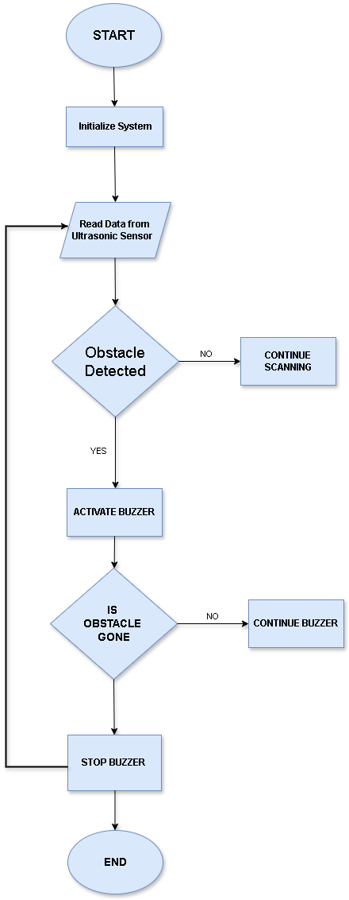

FIG 5. FLOWCHART

The **methodology** of this project is based on **sensor-based obstacle detection and real-time feedback** for visually impaired individuals. The system utilizes the **ESP-WROOM-32 microcontroller**, **ultrasonic sensors**, and **alert mechanisms** to assist users in navigation. The working process is illustrated in the provided **flowchart** and explained in the following steps:

#### ****Step 1: System Initialization****

* The ESP-WROOM-32 **initializes** all components, including the **ultrasonic sensor and buzzer**
* It continuously monitors the surrounding environment for obstacles.

#### ****Step 2: Obstacle Detection****

* The **ultrasonic sensor** emits ultrasonic waves and measures the time taken for the echo to return.
* The **distance** to the nearest object is calculated based on the time delay.

#### ****Step 3: Decision Making****

* If **no obstacle** is detected, the system continues scanning.
* If an **obstacle is detected** within a predefined range (e.g., 50 cm), the ESP-WROOM-32 **triggers an alert**.

#### ****Step 4: Alert Mechanism****

* The **buzzer produces an audible alert**.
* This ensures the user is notified of an obstacle **even in noisy environments**.

#### ****Step 5: Obstacle Clearance Check****

* The system checks if the obstacle is **still present**.
* If the obstacle is still there, the **buzzer continues**.
* If the obstacle is **no longer detected**, the system **stops the alert mechanism** and resets to scanning mode.

#### ****Step 6: Continuous Monitoring****

* The system **repeats the process** to ensure **real-time assistance** without requiring manual intervention.

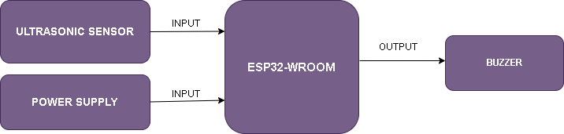

FIG 6. BLOCK DIAGRAM

The **block diagram** represents the fundamental components and their interconnections in the **ESP32-C3-Based Smart Blind Stick**. Each block defines a **specific module** responsible for the system's overall functionality.

#### ****1. ESP-WROOM-32Microcontroller (Central Unit)****

* The **ESP-WROOM-32** acts as the **brain** of the system, processing sensor data and controlling output devices.
* It receives **input signals** from the **ultrasonic sensor** and triggers the **buzzer accordingly.**

#### ****2. Ultrasonic Sensor (Obstacle Detection)****

* The **ultrasonic sensor** emits **ultrasonic waves** and measures the time taken for the echo to return.
* This helps in calculating the **distance of obstacles** in the user's path.
* If an obstacle is detected **within a predefined range**, it sends a signal to the ESP32.

#### ****3. Power Supply****

* Provides **operating voltage** and **current** to the ESP32-WROOM and other components.
* Ensures **stable performance** of the smart blind stick.

#### ****4. Buzzer (Auditory Feedback)****

* When an obstacle is detected, the ESP-WROOM-32activates the **buzzer** to generate an **audio alert**.
* This helps the visually impaired person **identify obstacles through sound**.

### ****Working Mechanism Based on the Block Diagram:****

1. **ESP-WROOM-32 initializes** and continuously reads data from the ultrasonic sensor.
2. The **ultrasonic sensor detects obstacles** and sends data to the ESP32.
3. If an obstacle is **within range**, the ESP32-WROOM **activates the buzzer .**
4. If the obstacle is **cleared**, the alerts **stop**, and the system **resumes scanning**.

This block diagram visually simplifies the **hardware interactions** in the project, ensuring **efficient obstacle detection and user assistance**.

## Expected Outcome

The **Smart Blind Stick** aims to provide a **practical and efficient solution** for visually impaired individuals by improving their ability to **navigate safely and independently**. The expected outcomes of the project include:

**• Enhanced Mobility and Safety:**

* The system enables users to **detect obstacles before physical contact**, reducing the risk of accidents and improving **confidence in movement**.
* The combination of **auditory (buzzer) and tactile () alerts** ensures accessibility in **various environments**, including noisy surroundings.

**• Cost-Effective and Scalable Design:**

* Using **affordable components** like **ESP-WROOM-32, ultrasonic sensors, buzzers** makes the system **economically viable**.
* The **modular design** allows for **future enhancements**, such as **GPS tracking, voice assistance, or AI-based object recognition**, making it adaptable to evolving needs.

**• Real-World Implementation Potential:**

* The device can be adopted in **rehabilitation centers** and **assistive technology projects** to help visually impaired individuals **regain mobility**.
* Its **simple design and ease of use** make it suitable for **widespread deployment**, including **personal use** and integration with existing mobility aids.

This project highlights the potential of **sensor-based assistive technology** in improving the **quality of life** for visually impaired individuals while maintaining **affordability and ease of implementation**.

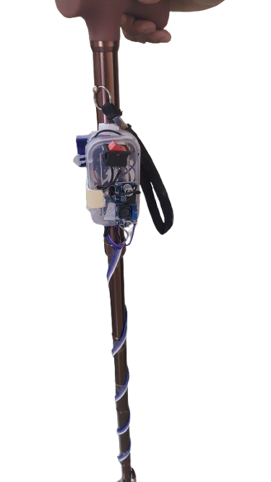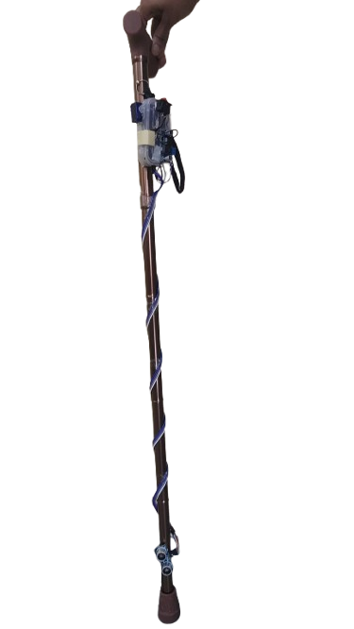

FIG. 7 PROJECT

### ****Future Scope****

As part of future development, our team is working on advancing the current prototype by implementing the **ESP32- C3 chip**, which offers a more compact form factor, lower power consumption, and enhanced wireless capabilities compared to the ESP32-WROOM-32. This upgrade aims to make the device more efficient, responsive, and suitable for long-term portable usage.

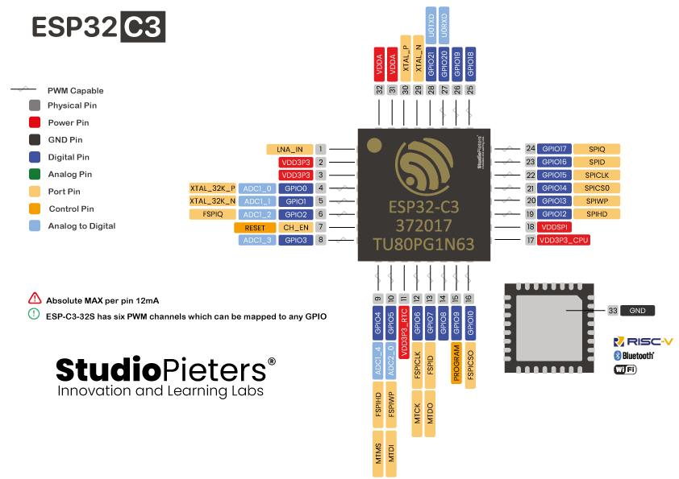

FIG. 8 ESP-32 C3 CHIP

Additionally, we are exploring **3D printing** technology to design a **custom, ergonomic enclosure** for the Smart Blind Stick. This will allow us to integrate all components—including the microcontroller, sensors, buzzer, and power supply—into a **streamlined and aesthetically pleasing body**. The 3D-printed case will enhance both **durability and usability**, making the final product more **compact, presentable, and user-friendly**.



FIG. 9 3D PRINTER

These enhancements will significantly elevate the practicality of the device, paving the way for **real-world deployment**, and potentially enabling mass production for widespread adoption by visually impaired users.

### ****Conclusion****

The Smart Blind Stick using ESP-WROOM-32 successfully demonstrates a practical and innovative solution to enhance the mobility and safety of visually impaired individuals. By integrating ultrasonic sensors, a buzzer, and a rechargeable power supply with a powerful microcontroller, the system provides real-time obstacle detection and audio feedback, significantly reducing the risk of collisions.

This project showcases how affordable, off-the-shelf components can be combined into a reliable and scalable assistive device. Its modular design not only ensures ease of use and maintenance but also offers vast potential for future enhancements such as GPS integration, voice assistance, and AI-based obstacle classification.

Through careful hardware selection, efficient programming, and focused user-centric design, the Smart Blind Stick serves as a promising step toward empowering the visually impaired with greater independence and confidence in their daily navigation.

## References

[1] V. B. Arepalli, “Smart Blind Stick Using ESP32,” Int. J. Res. Appl. Sci. Eng. Technol. (IJRASET), vol. 12, no. 3, pp. 3404–3409, Mar. 2024.  
[2] R. Hasan, M. J. Nayeem, and M. R. Islam, “A Smart Blind Stick for Persons with Visual Impairment,” SSRN Electron. J., Feb. 2023.  
[3] H. Sharma, M. Tripathi, A. Kumar, and M. S. Gaur, “Embedded Assistive Stick for Visually Impaired Persons,” in Proc. Int. Conf. Comput., Commun., Autom. (ICCCA), Dec. 2019, pp. 1–6.  
[4] M. Kumar, R. Sharma, and A. Verma, “Low Cost Smart Stick for Blind and Partially Sighted People,” Int. J. Adv. Res. Sci. Commun. Technol. (IJARSCT), vol. 3, no. 5, pp. 345–350, May 2021.  
[5] M. Nasir, A. Rahman, and F. Ahmed, “Development of a Smart Walking Stick for Visually Impaired Individuals,” in Proc. IEEE Robot. Autom. Conf., 2022, pp. 1–5.  
[6] A. P. Pagar, S. D. Pawar, and M. S. Jadhav, “Design and Implementation of an Intelligent Walking Stick for the Blind,” Int. J. Eng. Res. Technol. (IJERT), vol. 6, no. 4, pp. 102–107, 2023.